

**PROJECT DOCUMENTS**

**Project Title**

**Nutrients and Food groups**

**Team Number &** **Teammates:**

**720722104018 –** *Kandasamy E*

**720722104028 –** *Pavithra C*

**720722104807 –** *Kishone Shree Lal*

**Dept: B.E.CSE  
 Year: 2nd yr**

**Description:**

Let's delve deeper into each category:

1. Protein:
   * **Meat:**
     + Provides high-quality protein containing all essential amino acids required for muscle repair and growth.
     + Rich in vitamins such as B vitamins (B12, niacin, riboflavin) and minerals like iron and zinc.
     + Types include beef, pork, lamb, and poultry (chicken, turkey), each offering distinct flavors and nutritional profiles.
   * **Fish:**
     + Excellent source of lean protein and essential omega-3 fatty acids, which support heart health and brain function.
     + Varieties include fatty fish like salmon, mackerel, and trout, as well as lean options like cod, tilapia, and tuna.
     + Provides vitamins D and B12, iodine, and minerals like selenium.
   * **Eggs:**
     + Highly nutritious, offering high-quality protein, vitamins (B12, riboflavin), and minerals (selenium).
     + Contains all essential amino acids, making it a complete protein source.
     + Provides lutein and zeaxanthin, antioxidants important for eye health.
   * **Dairy:**
     + Rich in calcium, essential for bone health, and protein, vital for muscle and tissue repair.
     + Provides vitamins D (especially in fortified products), A, B12, and riboflavin.
     + Options include milk, cheese, yogurt, and butter, with varying fat content and flavor profiles.
   * **Legumes:**
     + Plant-based protein sources rich in fiber, vitamins (folate, B vitamins), and minerals (iron, potassium).
     + Include beans (black beans, kidney beans), lentils, chickpeas, and peas.
     + Provide complex carbohydrates for sustained energy and can be used in various dishes like soups, stews, and salads.
   * **Nuts:**
     + Dense sources of protein, healthy fats (monounsaturated and polyunsaturated), fiber, vitamins (E, B vitamins), and minerals (magnesium, zinc).
     + Offer cardiovascular benefits and may help reduce inflammation.
     + Varieties include almonds, walnuts, peanuts, cashews, and pistachios, each with unique nutritional profiles

2.Carbohydrates:

* + **Grains:**
    - Staple foods providing complex carbohydrates for energy, fiber for digestion, and essential nutrients like B vitamins and iron.
    - Examples include whole grains (brown rice, quinoa, oats) and refined grains (white rice, white bread), with whole grains offering more nutrients and fiber.
    - Versatile ingredients used in dishes like bread, pasta, cereals, and baked goods.
  + **Fruits:**
    - Natural sources of carbohydrates, vitamins (vitamin C, A, potassium), minerals, fiber, and antioxidants.
    - Offer sweetness and flavor in various forms like berries, citrus fruits, apples, bananas, and tropical fruits.
    - Can be enjoyed fresh, dried, or as fruit juices, contributing to a balanced diet and overall health.
  + **Vegetables:**
    - Low-calorie, nutrient-dense foods providing carbohydrates, fiber, vitamins (vitamin A, C, K), minerals (potassium, magnesium), and phytonutrients.
    - Include leafy greens, cruciferous vegetables, root vegetables, and nightshades, each offering unique health benefits.
    - Contribute to satiety, promote digestive health, and reduce the risk of chronic diseases when consumed regularly.
  + **Sugars:**
    - Simple carbohydrates providing quick energy but lacking in nutritional value when consumed in excess.
    - Found naturally in fruits, honey, and maple syrup, as well as added to processed foods and beverages as refined sugars (sucrose, high-fructose corn syrup).
    - Consumption should be moderated to prevent spikes in blood sugar levels and reduce the risk of obesity and metabolic disorders.

1. Fats:
   1. **Saturated Fats:**
      1. Solid at room temperature, found mainly in animal products like meat, dairy, and butter, as well as tropical oils like coconut oil and palm oil.
      2. Consumption should be limited to prevent elevated LDL cholesterol levels and reduce the risk of heart disease.
   2. **Trans Fats:**
      1. Artificially produced through hydrogenation, found in processed foods like margarine, fried foods, and baked goods.
      2. Highly detrimental to heart health, increasing LDL cholesterol and inflammation while decreasing HDL cholesterol.
      3. Consumption should be minimized or avoided altogether.
   3. **Monounsaturated Fats:**
      1. Liquid at room temperature, found in foods like olive oil, avocados, and nuts.
      2. Promote heart health by lowering LDL cholesterol levels and reducing inflammation.
      3. Should be included in a balanced diet as a healthier fat option.
   4. **Polyunsaturated Fats:**
      1. Essential fats found in fatty fish (salmon, mackerel), flaxseeds, walnuts, and soybean oil.
      2. Provide omega-3 and omega-6 fatty acids important for brain function, heart health, and reducing inflammation.
      3. Should be consumed in moderation as part of a balanced diet to maintain optimal health.
2. Fiber:
   1. **Soluble Fiber:**
      1. Dissolves in water to form a gel-like substance, aiding digestion and promoting satiety.
      2. Found in foods like oats, beans, apples, citrus fruits, and flaxseeds.
      3. Helps lower cholesterol levels, stabilize blood sugar, and improve gut health.
   2. **Insoluble Fiber:**
      1. Does not dissolve in water, adding bulk to stool and facilitating bowel movements.
      2. Found in whole grains, nuts, seeds, and vegetables like broccoli, carrots, and celery.
      3. Promotes regularity, prevents constipation, and may reduce the risk of colon cancer.
3. Vitamins & Minerals:
   1. **Vitamin A:** Essential for vision, immune function, and skin health, found in foods like carrots, sweet potatoes, spinach, and liver.
   2. **Vitamin B:** Group of water-soluble vitamins involved in energy metabolism, nerve function, and red blood cell production, found in foods like whole grains, meat, fish, eggs, and leafy greens.
   3. **Vitamin C:** Antioxidant important for immune function, collagen synthesis, and wound healing, found in citrus fruits, strawberries, bell peppers, and broccoli.
   4. **Vitamin D:** Vital for calcium absorption, bone health, and immune function, found in fatty fish, fortified dairy products, and exposure to sunlight.
   5. **Vitamin E:** Antioxidant protecting cells from damage, found in nuts, seeds, vegetable oils, and leafy greens.
   6. **Vitamin K:** Essential for blood clotting and bone health, found in leafy greens, broccoli, Brussels sprouts, and fermented foods like natto.
   7. **Calcium:** Crucial for bone health, muscle function, and nerve transmission, found in dairy products, leafy greens, tofu, and fortified foods.
   8. **Iron:** Essential for oxygen transport and energy metabolism, found in meat, seafood, beans, lentils, spinach, and fortified cereals.
   9. **Magnesium:** Involved in hundreds of biochemical reactions, including energy production and muscle function

**6.** Water:

* for life and various bodily functions, including hydration, temperature Essential regulation, nutrient transport, waste removal, and lubrication of joints.
* Found in beverages like water, herbal teas, and infused water, as well as in foods with high water content like fruits and vegetables

**Data Visualization in Food Groups:**

Data Visualization techniques are used to represent the distribution of calorie intake across different food subgroups within each food group category. Here's how data visualization is utilized in this context:

1. Pie Chart:

- Used to show the percentage contribution of each food subgroup to the total calorie intake within a food group.

- Helps in understanding the relative proportion of calorie intake from different subgroups at a glance.

- **Declaration:**

create_pie_chart(data, subgroups, f'{group} Distribution - Pie Chart')

1. Bar Chart:

- Utilized to compare the absolute calorie intake values of different subgroups within a food group.

- Provides a clear visual comparison of calorie intake across subgroups.

- **Declaration:**

create_bar_chart(data, subgroups, f'{group} Distribution - Bar Chart')

3. Stacked Bar Chart:

- Shows the distribution of calorie intake across subgroups while also representing the total calorie intake for each subgroup.

- Useful for comparing both individual subgroup values and their contribution to the total intake.

**- Declaration:**

create_stacked_bar_chart([data], subgroups, f'{group} Distribution - Stacked Bar Chart')

4. Donut Chart:

- Similar to a pie chart but with a hole in the center.

- Presents the relative contribution of each subgroup to the total calorie intake within a food group.

- **Declaration:**

create_donut_chart(data, subgroups, f'{group} Distribution - Donut Chart')

5. Radar Chart:

- Used to visualize multivariate data in the form of a two-dimensional chart of three or more quantitative variables represented on axes starting from the same point.

- Each axis represents a different subgroup, and the distance from the center indicates the calorie intake.

- **Declaration:**

create_radar_chart([data], subgroups, f'{group} Distribution - Radar Chart').

**Code and Output :**

import matplotlib.pyplot as plt  
import seaborn as sns  
import numpy as np  
  
def create_pie_chart(data, labels, title):  
 plt.figure(figsize=(8, 8))  
 plt.pie(data, labels=labels, autopct='%1.1f%%', startangle=140)  
 plt.axis('equal')  
 plt.title(title)  
 plt.show()  
  
def create_bar_chart(data, labels, title):  
 plt.figure(figsize=(10, 6))  
 sns.barplot(x=labels, y=data)  
 plt.title(title)  
 plt.xlabel('Food Subgroups')  
 plt.ylabel('Calorie Intake')  
 plt.xticks(rotation=45, ha='right')  
 plt.tight_layout()  
 plt.show()  
  
def create_stacked_bar_chart(data, labels, title):  
 plt.figure(figsize=(10, 6))  
 bottom = np.zeros(len(labels))  
 for d in data:  
 plt.bar(labels, d, bottom=bottom)  
 bottom += np.array(d)  
 plt.title(title)  
 plt.xlabel('Food Subgroups')  
 plt.ylabel('Calorie Intake')  
 plt.xticks(rotation=45, ha='right')  
 plt.tight_layout()  
 plt.legend(labels)  
 plt.show()  
  
def create_donut_chart(data, labels, title):  
 plt.figure(figsize=(8, 8))  
 plt.pie(data, labels=labels, autopct='%1.1f%%', startangle=140)  
 centre_circle = plt.Circle((0, 0), 0.70, fc='white')  
 fig = plt.gcf()  
 fig.gca().add_artist(centre_circle)  
 plt.axis('equal')  
 plt.title(title)  
 plt.show()  
  
def create_radar_chart(data, labels, title):  
 categories = labels  
 N = len(categories)  
 angles = [n / float(N) * 2 * np.pi for n in range(N)]  
 angles += angles[:1]  
 ax = plt.subplot(111, polar=True)  
 plt.xticks(angles[:-1], categories, color='black', size=10)  
 ax.set_rlabel_position(0)  
 plt.yticks(color="grey", size=8)  
 plt.ylim(0, max(data[0]))  
 for d in data:  
 d += d[:1]  
 ax.plot(angles, d, linewidth=1, linestyle='solid')  
 ax.fill(angles, d, 'b', alpha=0.1)  
 plt.title(title, size=20, color='black', y=1.1)  
 plt.show()  
  
def main():  
 food_groups = {  
 "Protein": ["Meat", "Fish", "Eggs", "Dairy", "Legumes", "Nuts"],  
 "Carbohydrates": ["Grains", "Fruits", "Vegetables", "Sugars"],  
 "Fats": ["Saturated Fats", "Trans Fats", "Monounsaturated Fats", "Polyunsaturated Fats"],  
 "Fiber": ["Soluble Fiber", "Insoluble Fiber"],  
 "Vitamins & Minerals": ["Vitamin A", "Vitamin B", "Vitamin C", "Vitamin D", "Vitamin E", "Vitamin K",  
 "Calcium", "Iron", "Magnesium", "Potassium", "Sodium", "Zinc"],  
 "Water": ["Water"]  
 }  
  
 for group, subgroups in food_groups.items():  
 data = []  
 print(f"Enter calorie intake for {group}:")  
 if len(subgroups) == 1:  
 intake = float(input(f" - {subgroups[0]}: "))  
 data.append(intake)  
 else:  
 for subgroup in subgroups:  
 intake = float(input(f" - {subgroup}: "))  
 data.append(intake)  
  
 create_pie_chart(data, subgroups, f'{group} Distribution - Pie Chart')  
 create_bar_chart(data, subgroups, f'{group} Distribution - Bar Chart')  
 create_stacked_bar_chart([data], subgroups, f'{group} Distribution - Stacked Bar Chart')  
 create_donut_chart(data, subgroups, f'{group} Distribution - Donut Chart')  
 create_radar_chart([data], subgroups, f'{group} Distribution - Radar Chart')  
  
if __name__ == "__main__":  
 main()

Enter calorie intake for Protein:

- Meat: 200

- Fish: 150

- Eggs: 100

- Dairy: 120

- Legumes: 80

- Nuts: 70

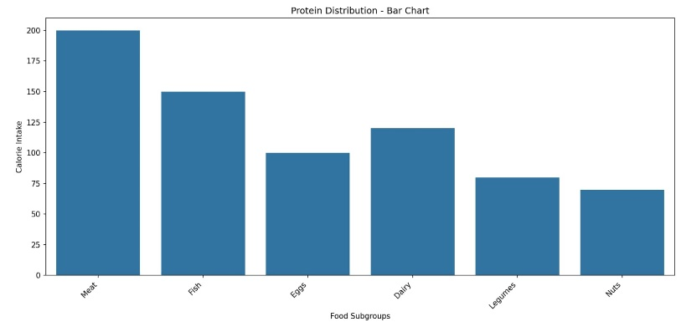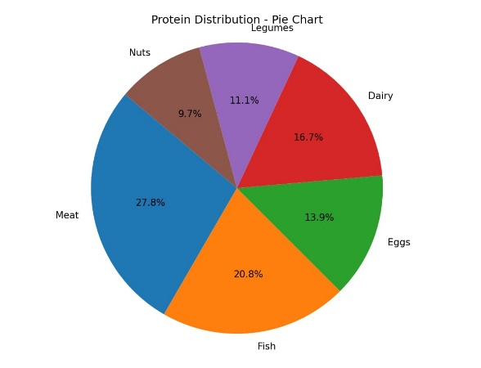

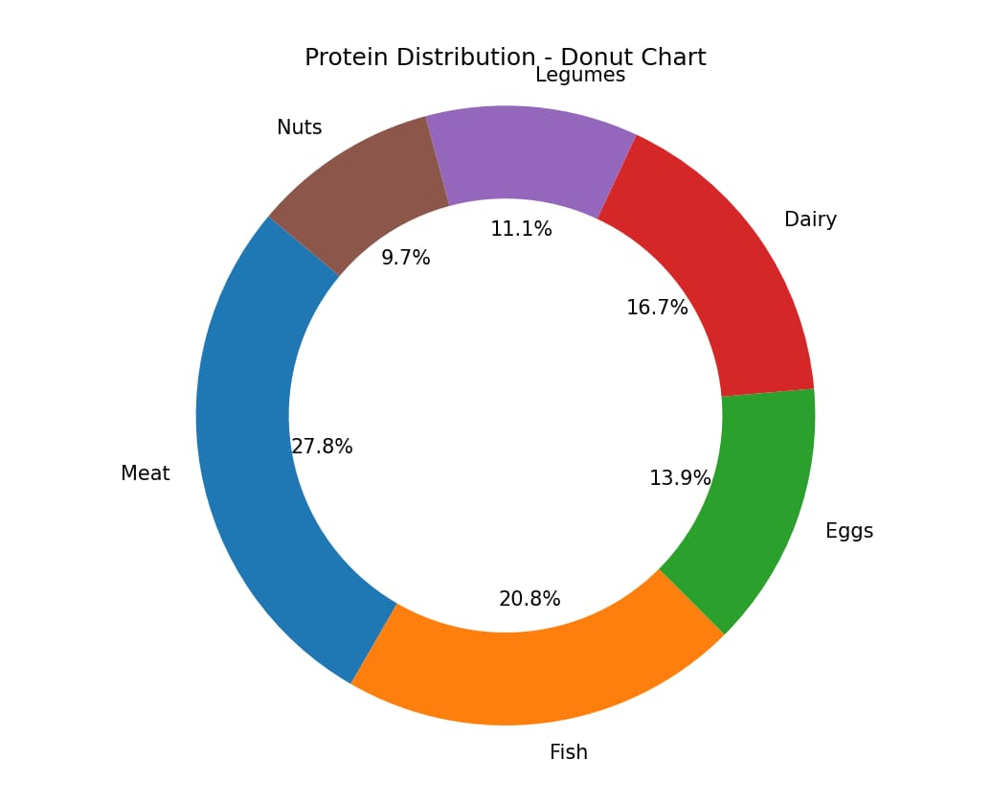

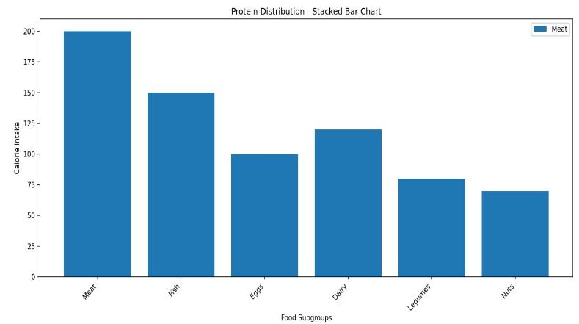

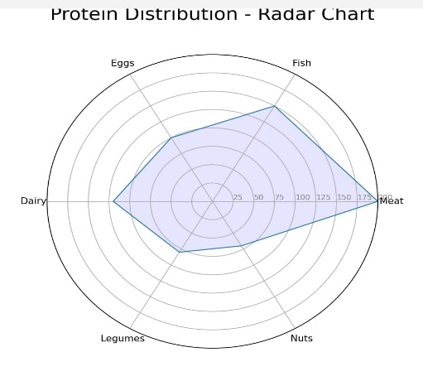

Enter calorie intake for Carbohydrates:

- Grains: 300

- Fruits: 250

- Vegetables: 200

- Sugars: 150

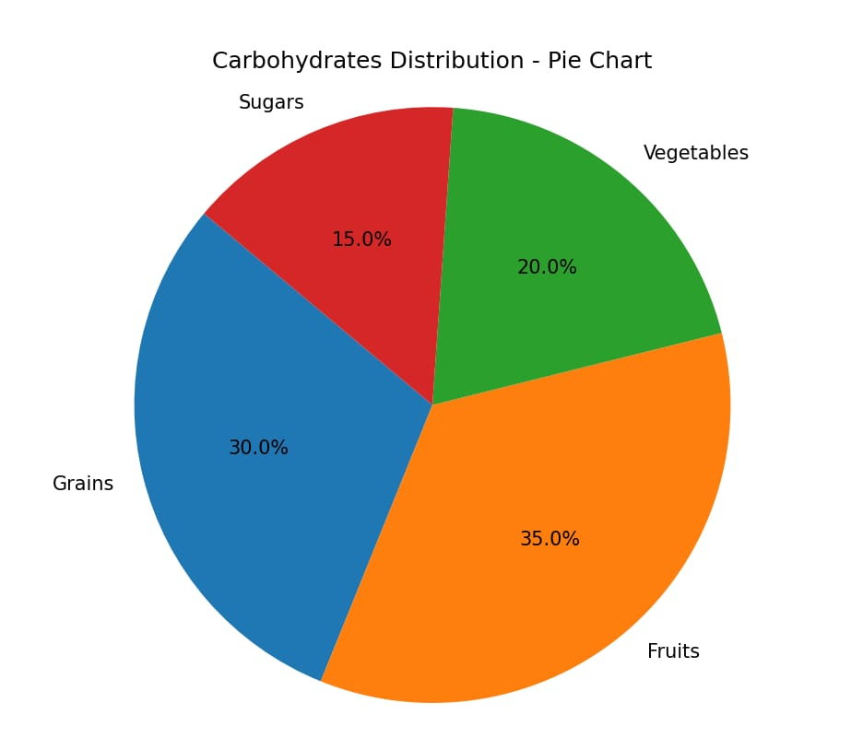

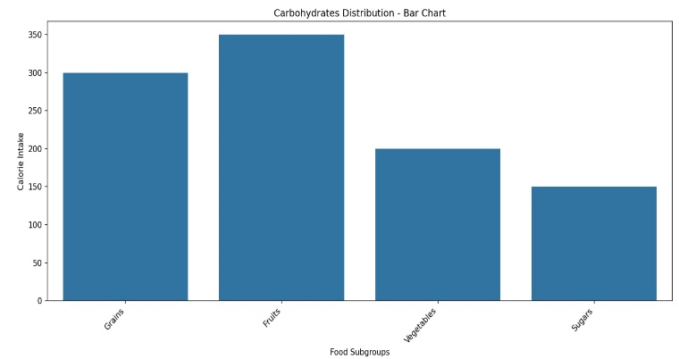

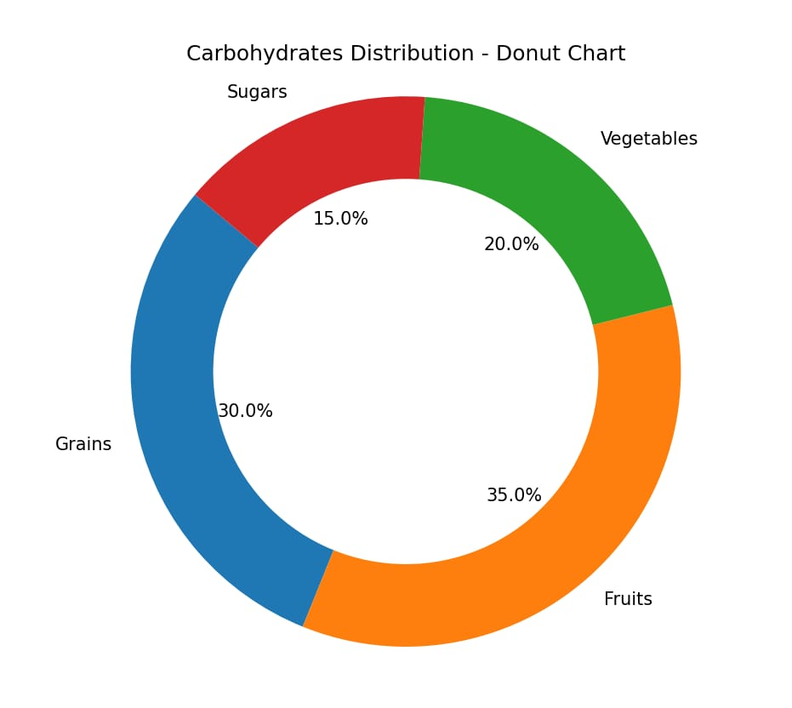

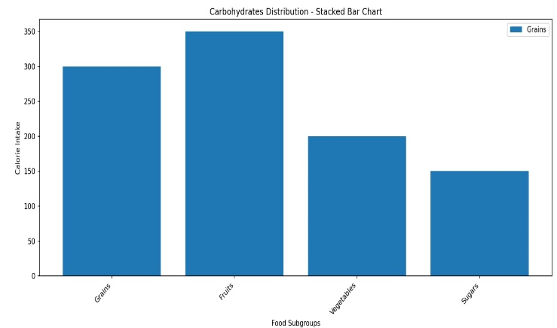

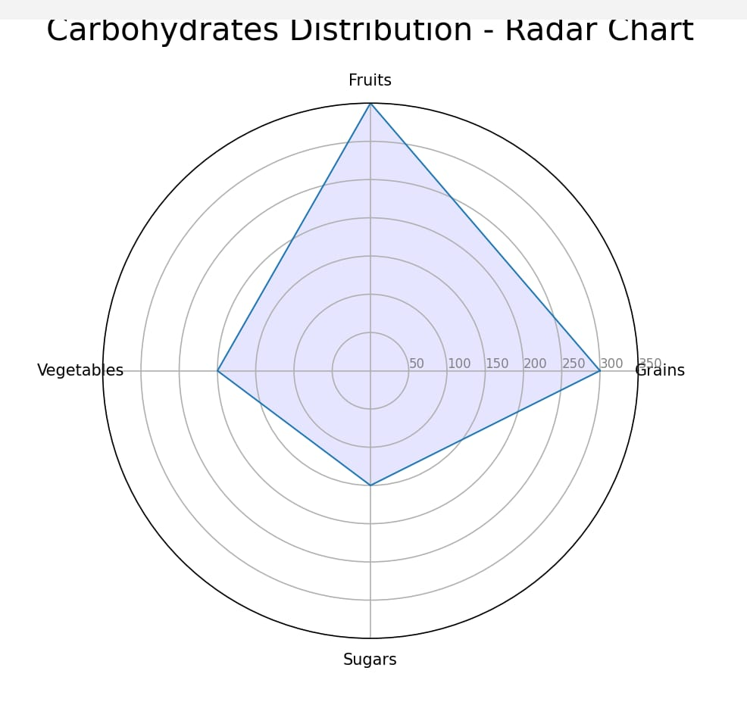

Enter calorie intake for Fats:

- Saturated Fats: 80

- Trans Fats: 40

- Monounsaturated Fats: 60

- Polyunsaturated Fats: 50

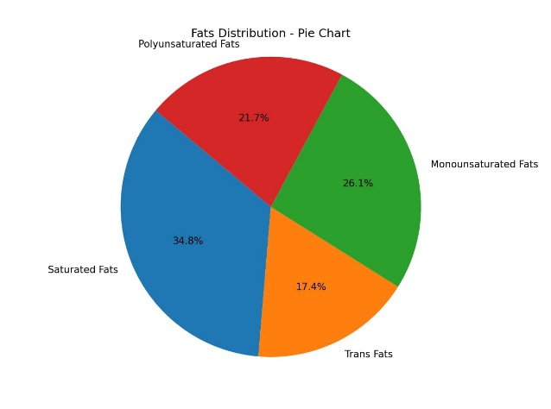

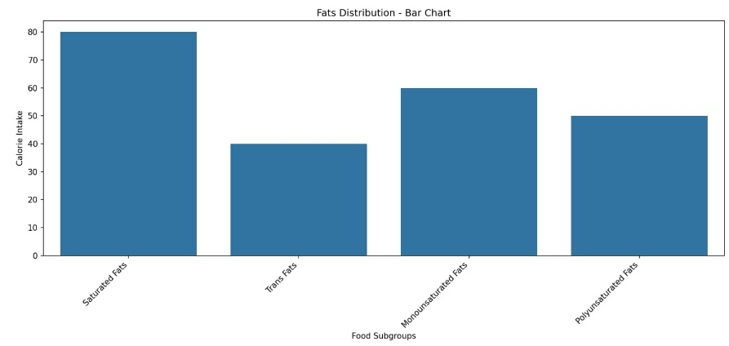

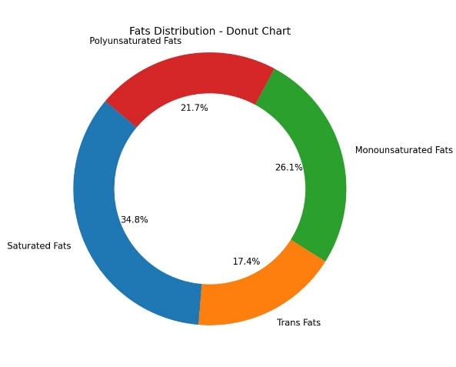

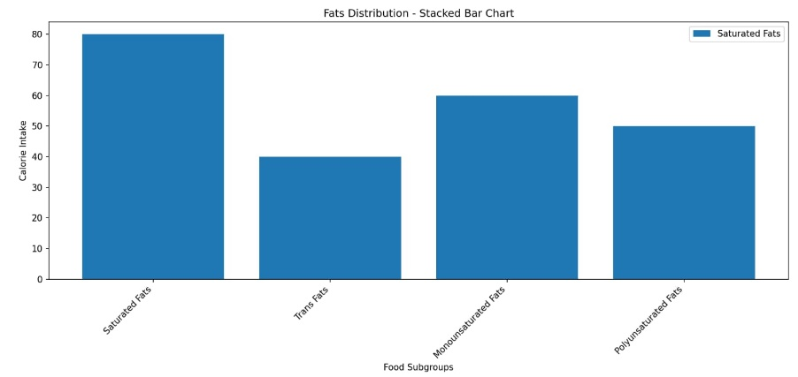

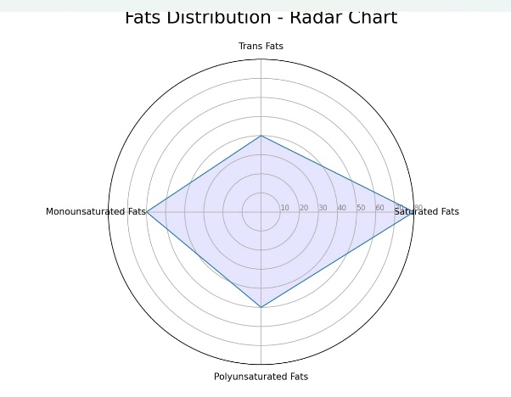

Enter calorie intake for Fiber:

- Soluble Fiber: 30

- Insoluble Fiber: 40

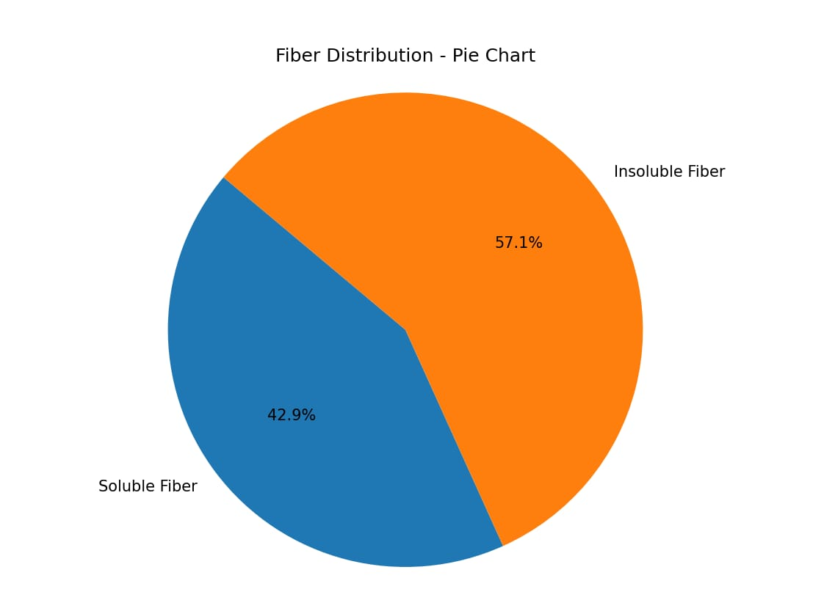

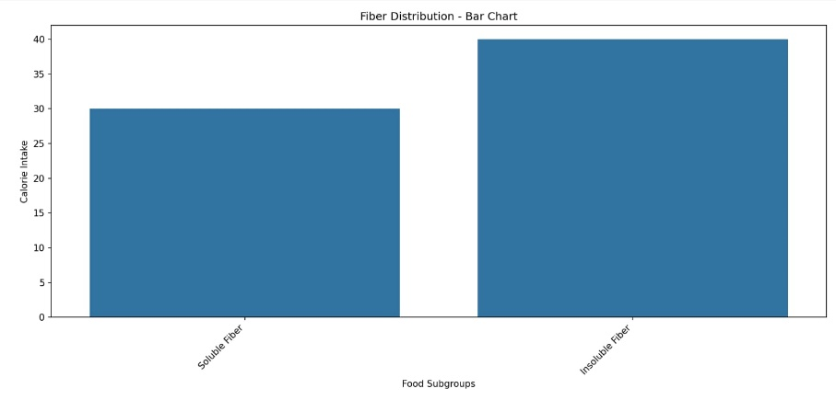

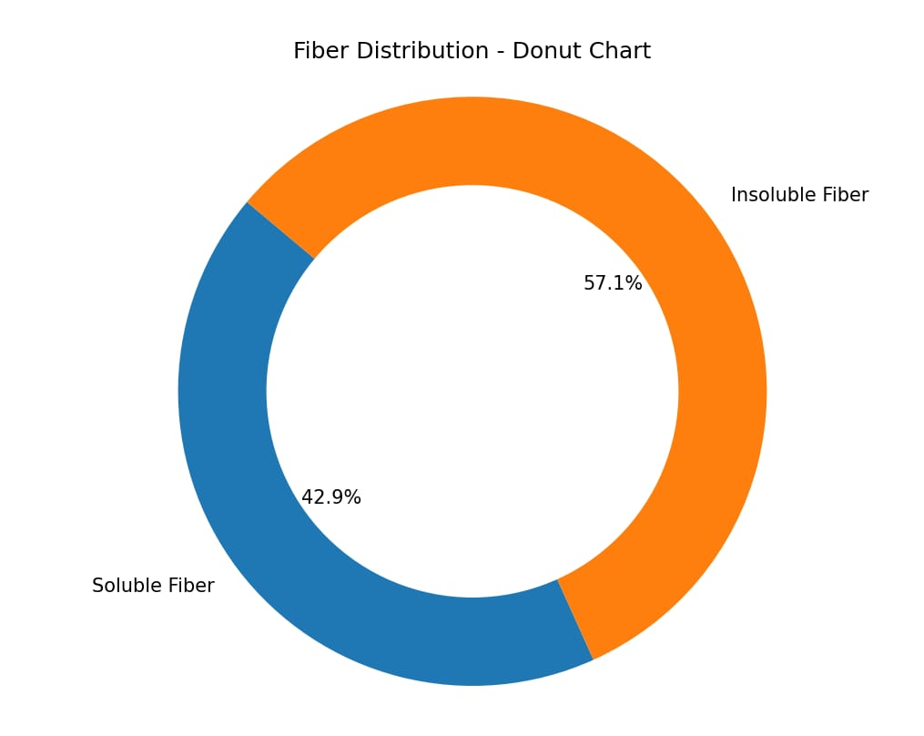

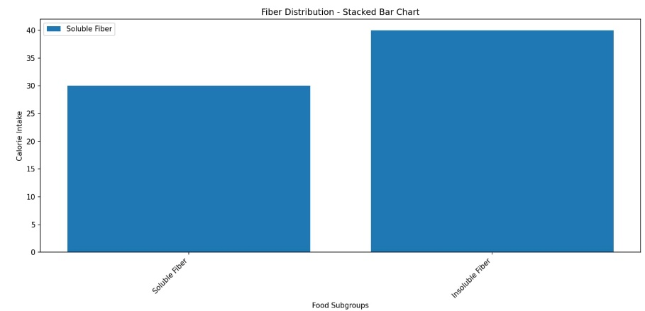

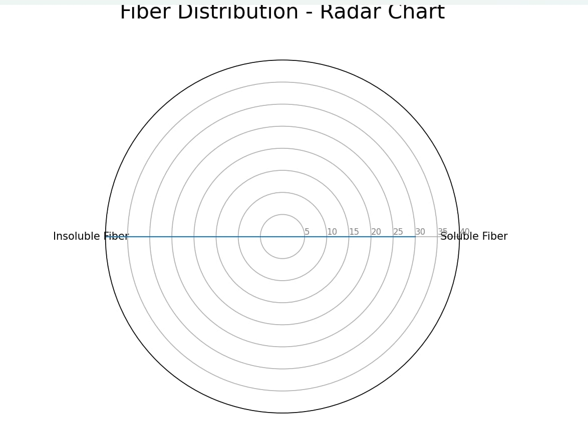

Enter calorie intake for Vitamins & Minerals:

- Vitamin A: 50

- Vitamin B: 60

- Vitamin C: 70

- Vitamin D: 40

- Vitamin E: 35

- Vitamin K: 45

- Calcium: 100

- Iron: 90

- Magnesium: 80

- Potassium: 120

- Sodium: 60

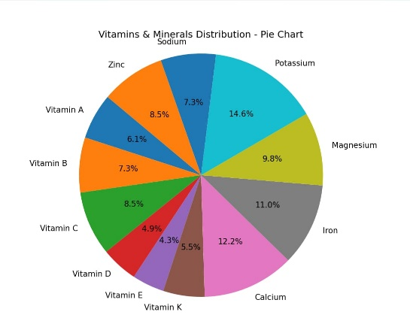 - Zinc: 70

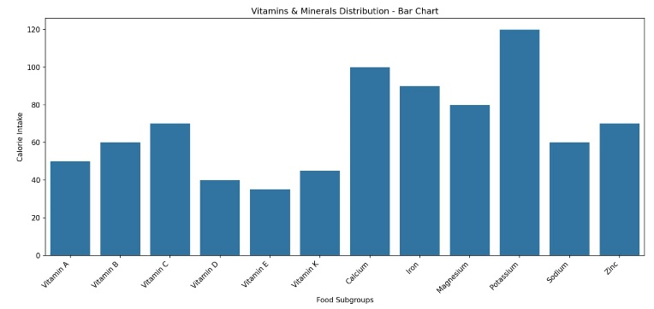

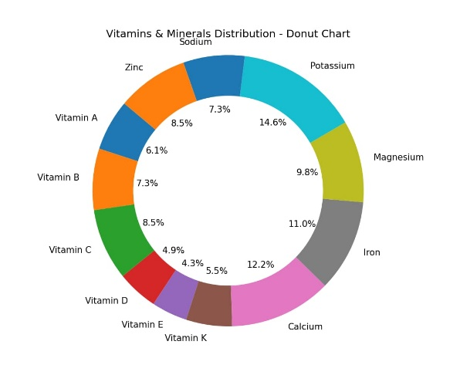

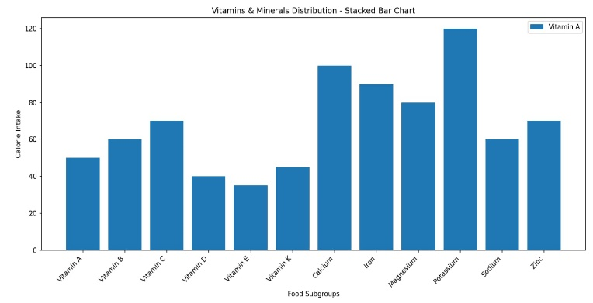

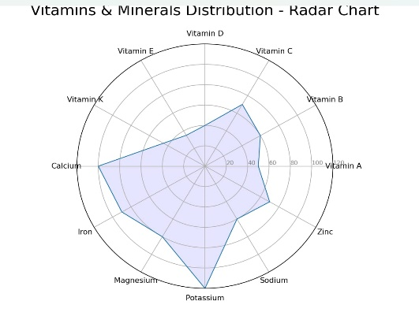

Enter calorie intake for Water:

- Water: 100

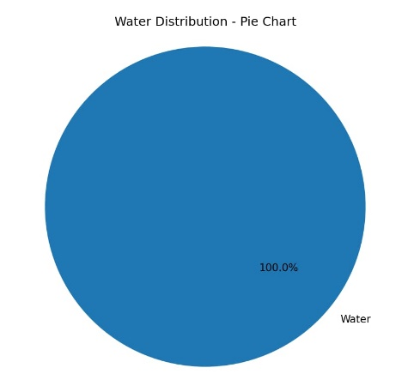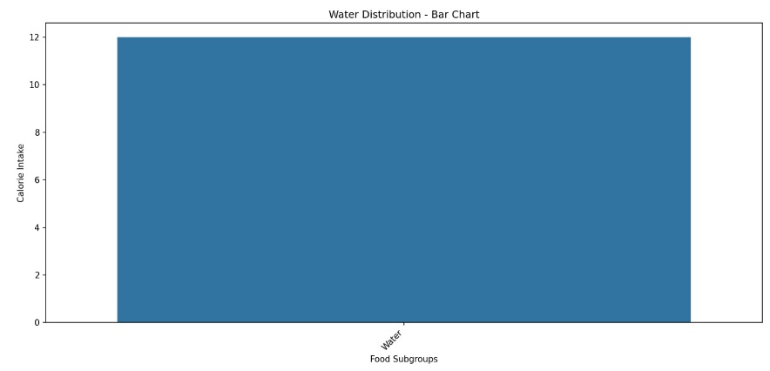

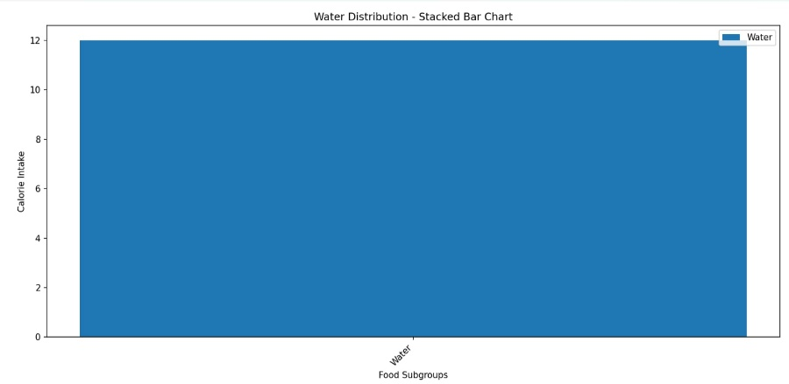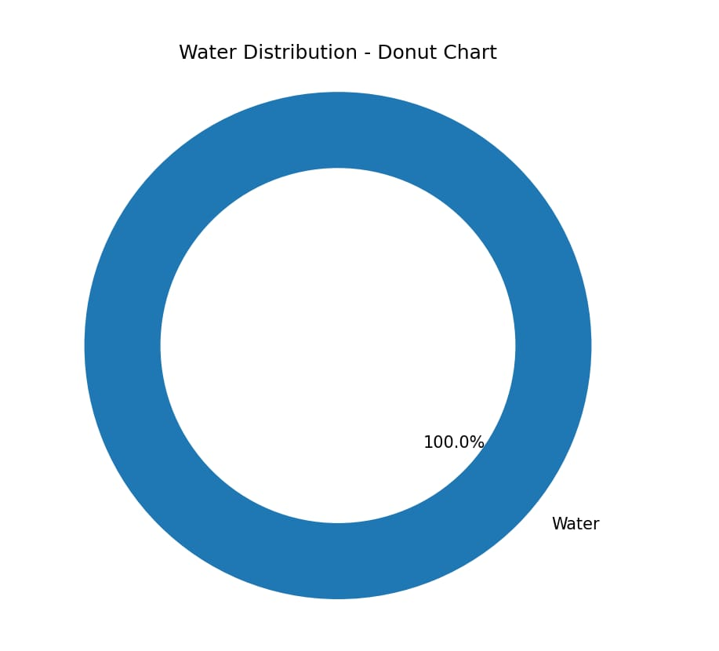

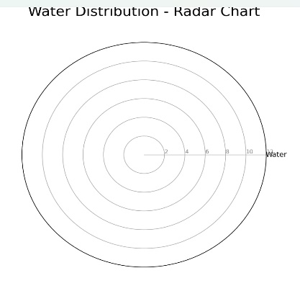

**Github Link :**

**https://github.com/Kandasamy7/Ibm.git**